# 简单SQL查询的实验报告

姓名 学号 班级 日期

## 一、实验目的

掌握非嵌套SQL查询用法.

## 二、实验内容

1. 运行脚本smallRelationsInsertFile.sql (见教学在线) 创建一个名为university数据库及其表格和数据.
2. 任选以上步骤中创建好的表格, 自己设计问题, 逐一展示如下命令的用法. 某些情况, 可能需要插入新的数据. 可参考教材例子.
   1. Natural Join
   2. String Operations: % _
   3. between
   4. Rename Operation: as
   5. order by
   6. min
   7. max
   8. sum
   9. count

## 三、实验环境

1. 操作系统: ????根据实际情况填写此处
2. 数据库: ????根据实际情况填写此处

## 四、实验步骤

1. 创建数据库并导入数据：

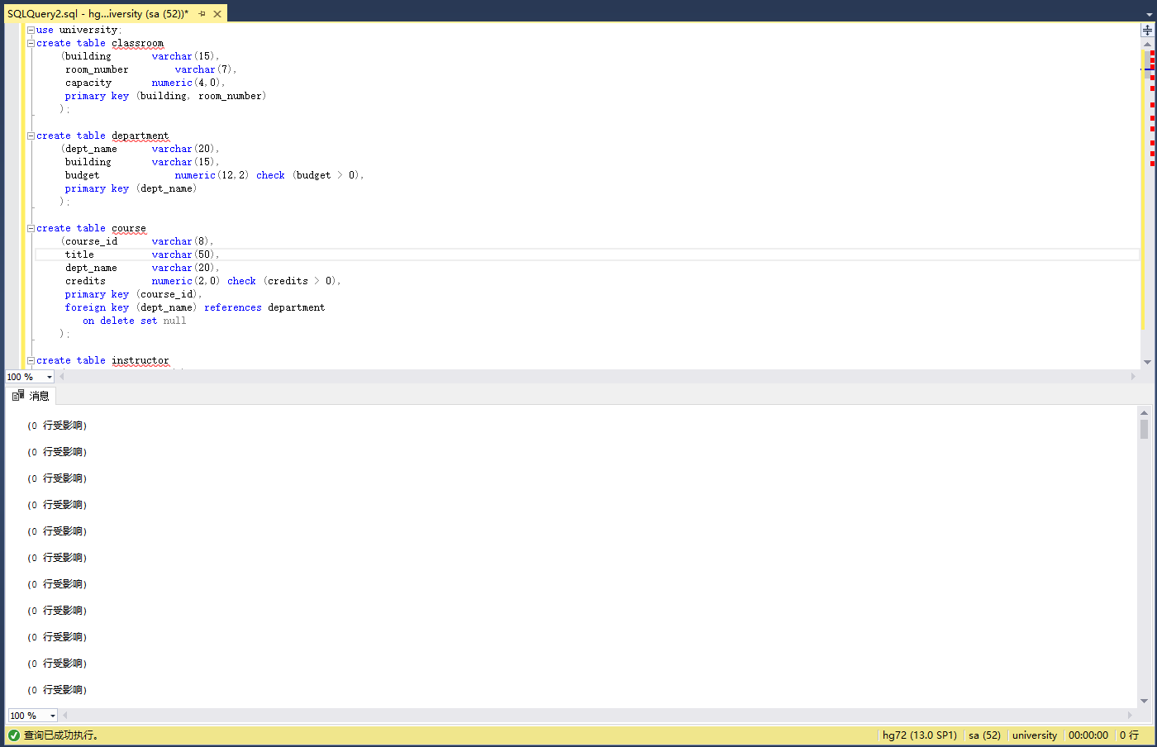

2. 设计问题并解决

a. 自然连接

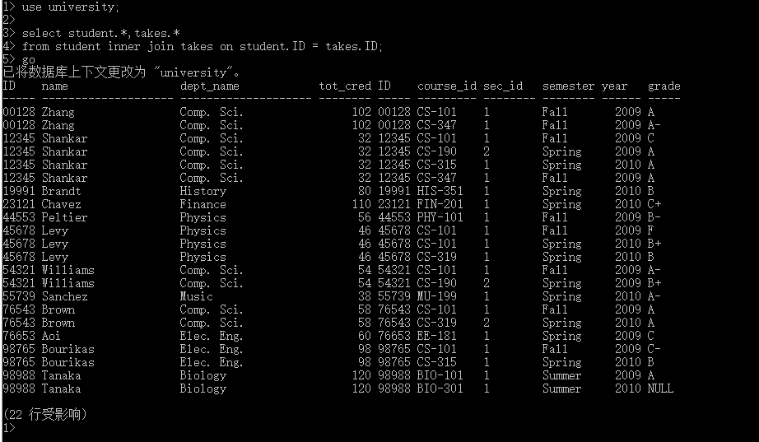

b． 字符串操作

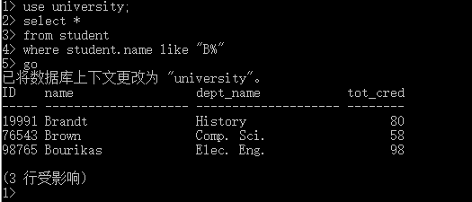

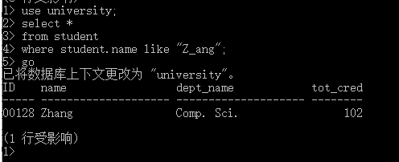

c. between

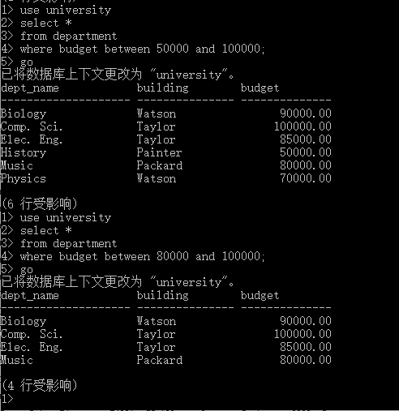

d. 重命名

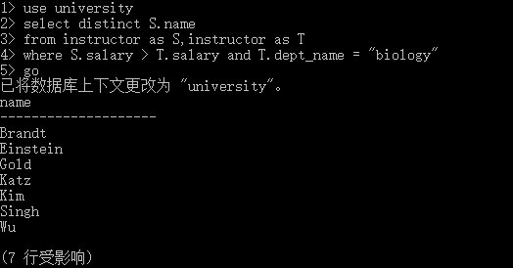

e. min

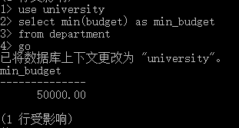

f. max

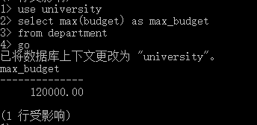

g. sum

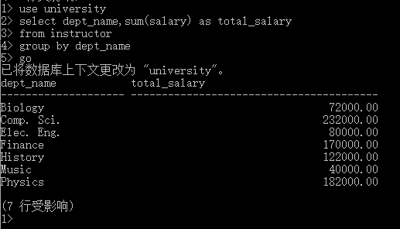

h. count

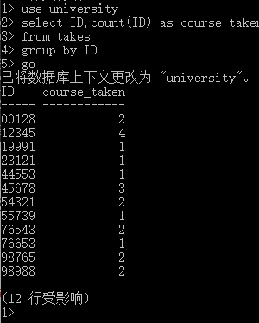

代码：

// Natural join

use university;

select student.*,takes.*

from student inner join takes on student.ID = takes.ID;

// String operation

use university;

select *

from student

where student.name like "B*";

use university;

select *

from student

where student.name like "Z_ang";

// Between

use university

select *

from department

where budget between 50000 and 100000;

// Rename

use university

select distinct S.name

from instructor as S,instructor as T

where S.salary > T.salary and T.dept_name = "biology"

// Min

use university

select min(budget) as min_budget

from department

// Max

use university

select max(budget) as max_budget

from department

// Count

use university

select ID,count(ID) as course_taken

from takes

group by ID

// Sum

use university

select dept_name,sum(salary) as total_salary

from instructor

group by dept_name

## 五、实验总结

可以写心得体会, 也可以写发现的问题, 没有硬性要求.